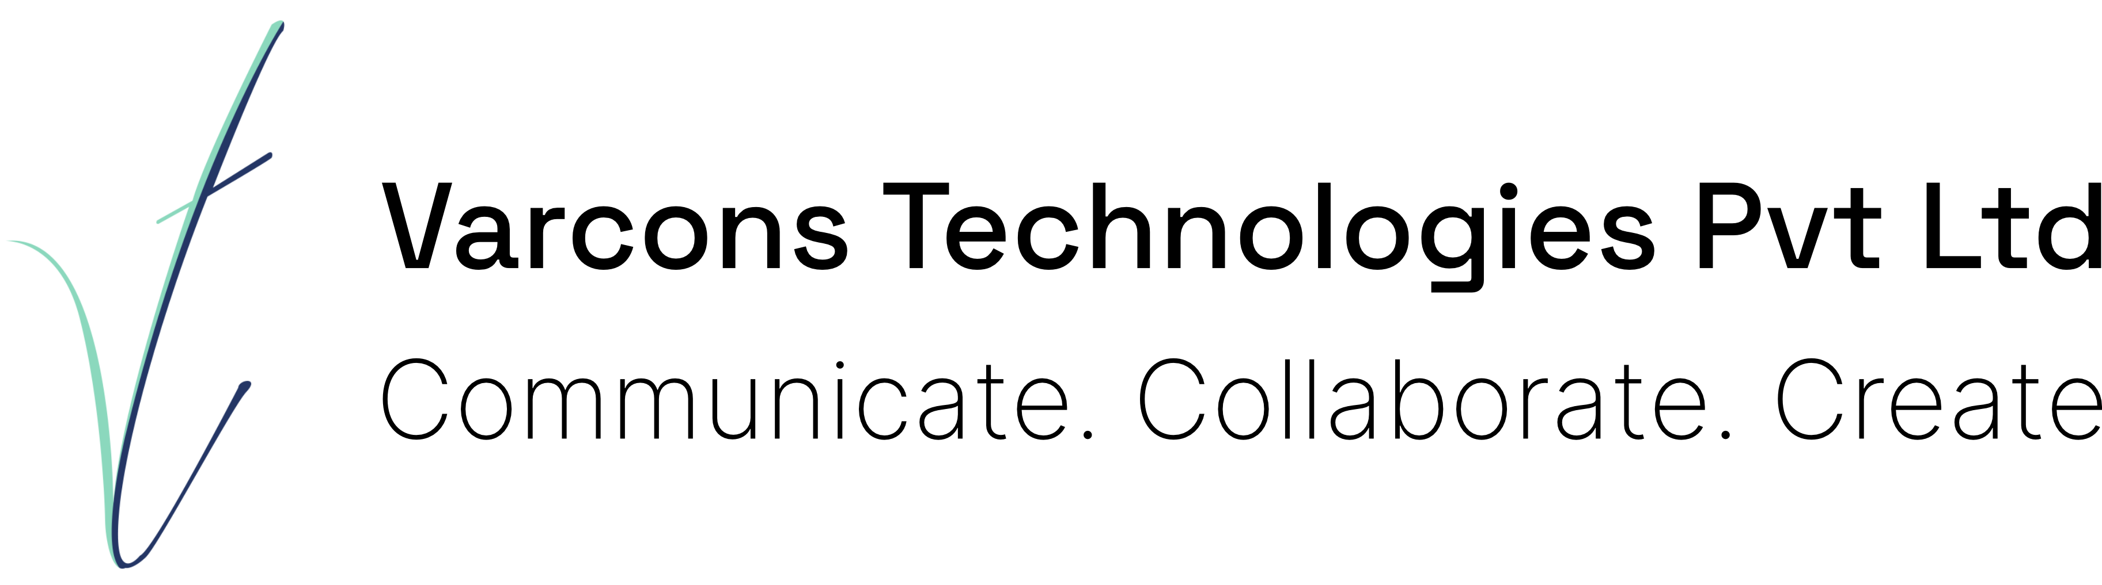

Certificate of Internship

This is to certify that **Sandeep Kumar L** whose USN is **4VM20IS035**, has completed their **Machine Learning With Python (Research Based)** Internship organised and handled by **Varcons Technologies Pvt. Ltd** from **13th August, 2023** to **20th September, 2023**.

The person to whom this certificate is addressed to has worked on a project titled **Machine Learning algorithms for Movie Recommendation System**, As part of the project, They designed the Machine Learning Model, Demonstrated and tested the working of the Model, Prepared a report highligt- ing its flaws by understanding the design briefs and client Specifications that were provided in the Proposal.

During the course of the internship, they demonstrated good design skills with a self-motivated attitude to learning new things. Their performance exceeded expectations and was able to complete the project successfully on time.

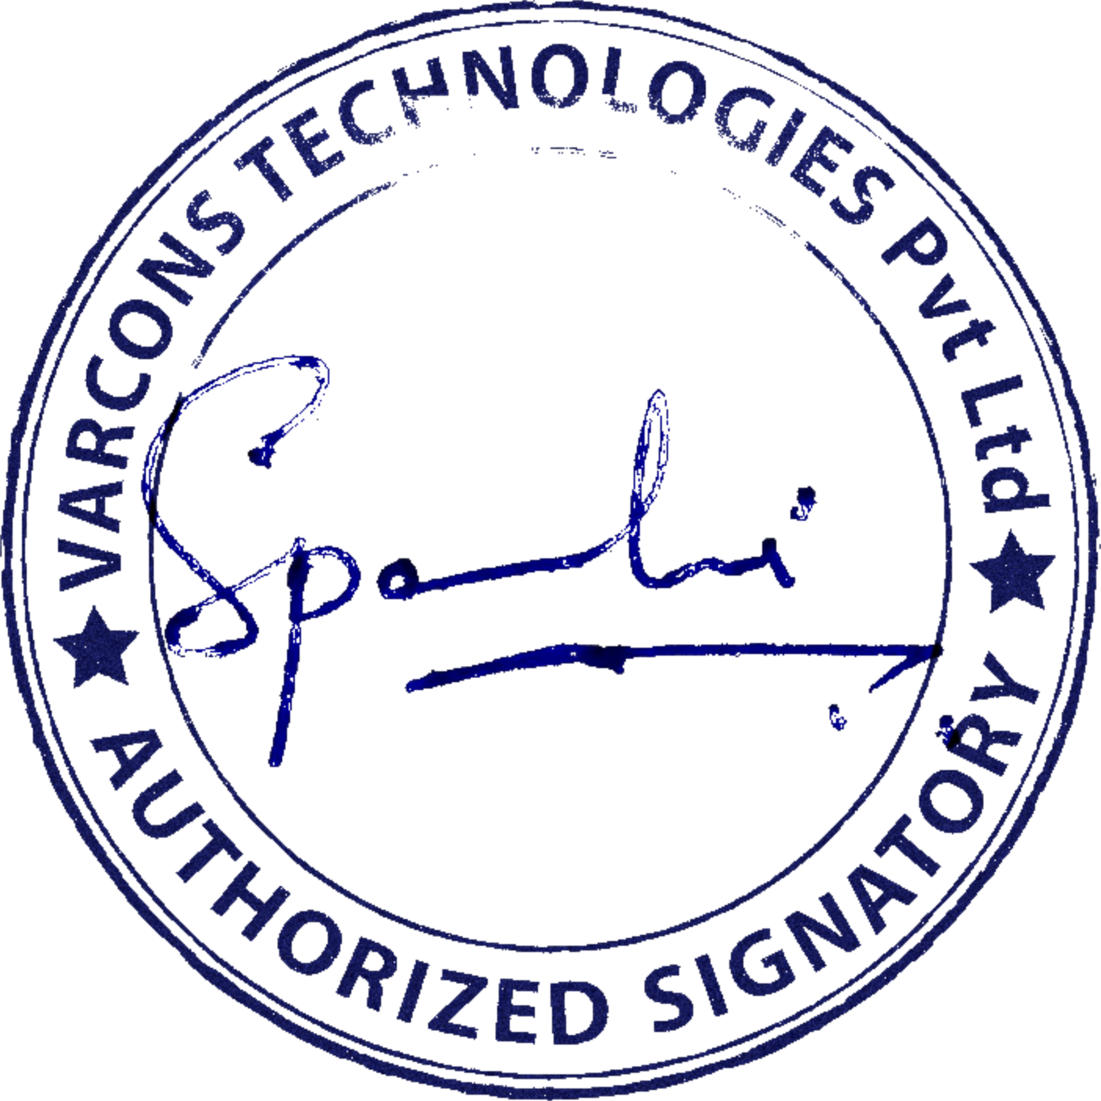To verify this certificate, [click here](https://v.certiefy.com/S0VZR0VOMuKLhaHHJrShQ00Ze03zZLuX6CSuMjhxwMtTTJfT0vqgaEEVdAxzL6BzGfdOPSAy_aejv-Ta3z3KvI6OK4r_F3bkdhfWQMoPimQgc8__7L5Dfvuvqh38WLDTyK5mUpqK2mQF3NKA9rtuc-4fqXpQbe9JEt_KlsQsG8ZIgt-WN1qlQbLwCaXR7wbobfax7111f0R44gHzfO0VV3nTbkeCjHIyLktdmBmp2MPgzARPdIujrAktvscC6eN_UyeEFb8dxIDcYllmYH2EzpJO3o2zxqr16W2-fsjOYuY_hkzKrQ6_PAyzni2KYpINYyG6BUzGOTIBzNhxUlfdvBLHkBkw5zA2vkG4EyMzHAqhlXX94FSzpy7oyqnMA6zxiPmKJlu3ItWBpeKLhdkFlRkaB3qxvQfcgBpMZE5roMHDxQ-NDnH9GSaDlD85) 

**Spoorthi C**

Director

Varcons

Technologies

Pvt.

Ltd [www.varconstech.com](https://varconstech.com/)

*213, 2st Floor,* [contact@varconstech.com](mailto:contact@varconstech.com)

*18 M G Road, Ulsoor, Bangalore-560001*

This certificate was generated using [CERTIEFY.COM](https://certiefy.com/)